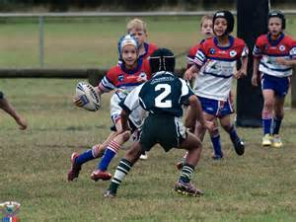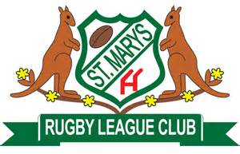

PESLE / DICKER UNDER 9s GALA DAY
EXPRESSION OF INTEREST Form

Club
Team / Division
Team Contact
Contact Phone
Contact Email

By entering this expression of interest, you acknowledge the following rules:

General Information
All players and officials must be registered to participate in 2017.
All players and officials must have a current card or photo copy of same.
There will be two conferences with a Trophy and a Plate final to be played after all round robin matches.

Ground rules
No BBQs are to be used other than those supplied by Emu Plains staff.
No Alcohol to be consumed at the grounds.
Swearing and bad behaviour will not be tolerated. Offenders may be asked to leave.

Game rules
All games will be 10 minutes each way with a one minute change over at halftime.
All games will start at 9:00am and every half hour.
No time off for injuries. Unlimited interchange will apply. Maximum 15 players per team.

Finals
There will Pools with the winners and runners up in each pool staying for the semi’s and Final.

Please send expression of interest by Friday 11th August to:
Kim Neal – Emu Plains JRLFC – epjrlfcsecretary@outlook.com
or
Therese Stivala – St Marys JRLFC – secretary.smjrl@gmail.com

